Q1 SecureServer.java

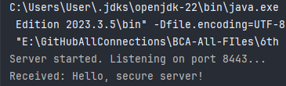

Q2 SecureClient.java

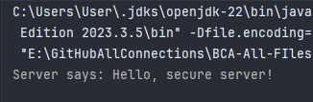

Q3 SecureClientEventHandler.java

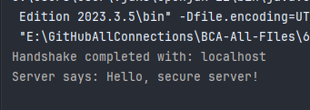

Q4